**Crossover Experiment**

I added another factor of complexity: **Phantom type**

* **Normal** (factory original density inserts and no air)
* **Expanded** (factory inserts + new adapted inserts + air)

**Step1**

**Model Fitting with all data to explore:**

ANOVA Type III indicates no difference between crosses, but effect of phantom type used and effect of different colonies

**Checking for multi-collinearity:**

Filter data to have only Type1 and Type2 crosses to better isolate effects. Then fit similar model with filtered data to check if significant effects remain after removing multi-collinearity by standardizing our response variable.

Visualize the data

**Removing outliers:**

Model with no outliers and with multicollinearity removed:

It seems effect of colony and Phantom Type remain, but cross type is not an issue, which is good as we want to prove that offsets from type1 and type2 crosses are not different.

**Step 2:**

Checking assumptions in fitted model before proceeding with figures, conclusions and statistical reporting :

1. **Homogeneity of variance assumption**

Found visual outliers and some minor ‘parabolic’ but we are just about good.

It can be useful to remove to ensure assumptions. However, if we run Levene’s test (see below) it give us reassurance that we can proceed.

According to Levene’s test we’re good. p-value is not less than the significance level of 0.05. This means that there is no evidence to suggest that the variance across groups is statistically significantly different. Therefore, we can assume the homogeneity of variances in the different treatment groups.

1. **Normality:**

As all the points, but a few remaining outliers, fall approximately along this reference line, we can assume normality.

The conclusion above, is supported by the **Shapiro-Wilk test** on the ANOVA residuals which finds no indication that normality is violated.

Now final model with Type III ANOVA to account for unbalanced design

**Step 3:**

Exploratory figures to better visualize effects

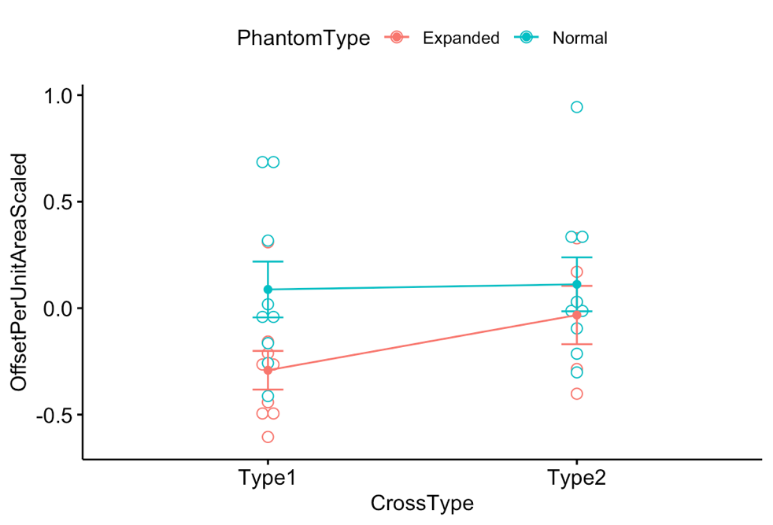

**Step 4:**

**Post hoc analyses to report pairwise effects**

Contrast between Type 1 and Type 2 🡪 not statistically different

*(good – it means we can do internal calibration, but as shown below – PhantomType matters).*

Contrast between Phantom Normal and Expanded 🡪

*statistically different – PhantomType matters.*

So let’s have a look at pairwise contrasts:

We see above that

Within Type1 – the kind of Phantom matters

Within type2 - the kind of phantom does not matter (but borderline – which also gives us a hint that we should have Expanded phantom from now on as I will show later).

**Results/ Take home message:**

**1 )** Overall model shows that effects of colony and phantom type on weight offset are predominant over cross type.

**2)** Type1 crosses produce mean offsets that are statistically different between Phantom Types (p-value=0.0013). Leads to think that a type1 cross is not reliable, because if you adopt it you will get different values based on the phantom you use *(good ! that’s what I wanted to show and proves we internal calibration is better)*

**3)** When adopting internal calibration (Type2 cross), we found weak evidence to support that an Expanded Phantom is better over a Normal Phantom (Contrast p-value=0.053)

*(maybe also helps justify scans we did in the past where we did not have an adapted phantom at hand - but we should still prefer Expanded Phantom to cover a wide range of possible density values, thus better constraining calibration curves).*

**Going back to hypotheses on page 1:**

Data above summarized in one figure:

H1: Offset largest for Type4 cross

**Answer**: Seems true, their boxplots show largest ranges.

H2: Offset is the **smallest** from **Type1 cross**, as Coral and Phantom do not interact. ​

**Answer**: False. Type2 offsets are comparable according to stats (see above, at least when using Expanded Phantom)

H3. The difference between Type1 and Type2 is statistically insignificant. ​

**Answer**: True (at least when using Expanded Phantom, good so can do internal calibration)

H4: Offset is **intermediate**from Type3. I’d expect the offset from Type3< Type4, as phantom volume is less affected by interaction with coral. ​

**Answer**: Not tested (not useful).